Prompt Iteration Log
Track: Refresh / Content Opportunity Scoring

Real Task
My task from the FL-01 audit is to analyze a Content Refresh dataset and identify which pages should be refreshed first based on SEO metrics.

Version 0 – Naive Prompt

Prompt
Analyze this Content Refresh dataset.

Version 1 – Technique: Role Assignment

Prompt
You are an SEO analyst. Analyze this Content Refresh dataset and identify which pages should be refreshed first.

Representative Output
The response focused on SEO priorities instead of giving general data analysis advice.

What Changed
Giving the AI a role made the response more relevant to SEO and content optimization.

Version 2 – Technique: Context and Motivation

Prompt
You are an SEO analyst. Analyze this Content Refresh dataset. The goal is to help a content team decide which pages should be refreshed first to improve search performance.

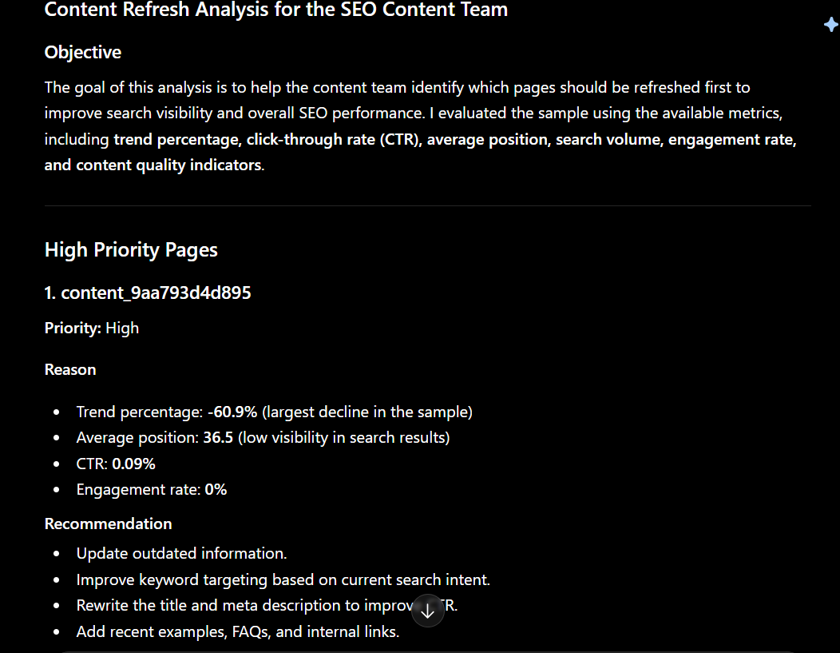

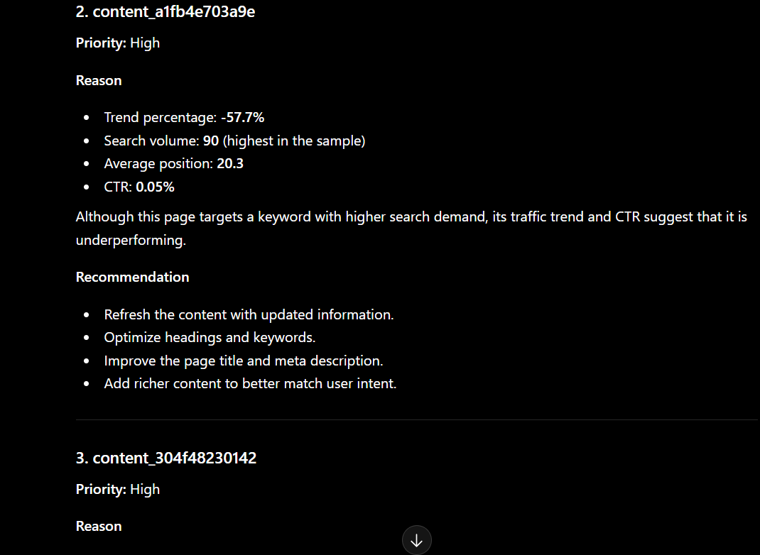

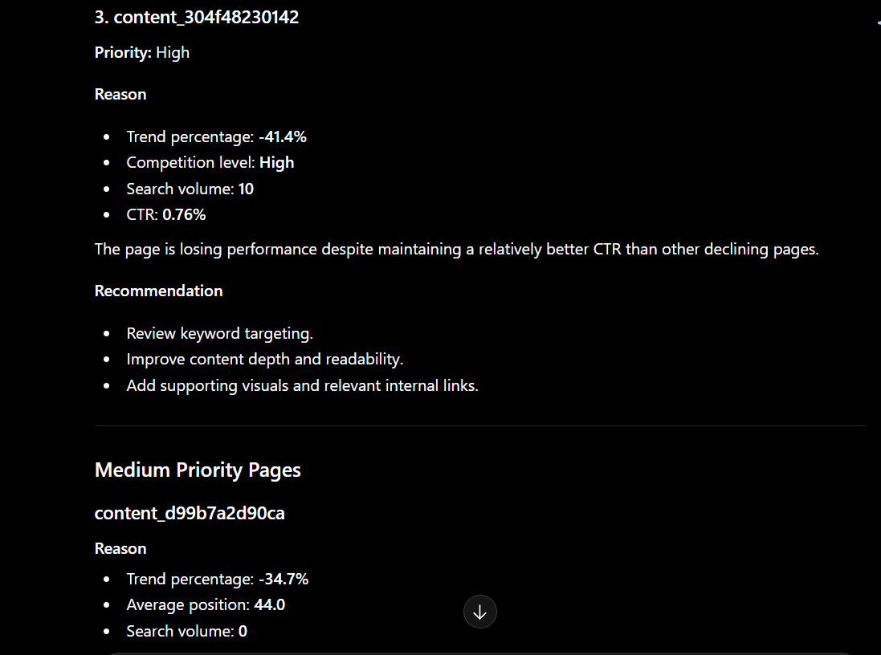

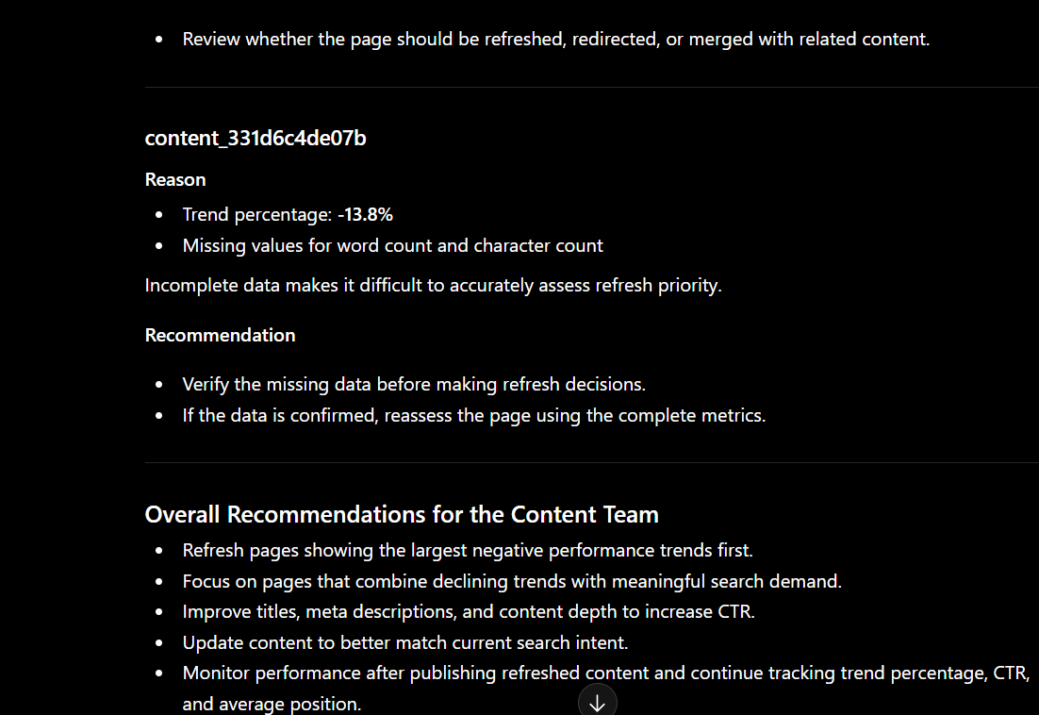

Representative Output
The response connected the analysis to business decisions and explained why refresh recommendations matter.

What Changed
Adding context made the recommendations more practical and aligned with the real business objective.

Version 3 – Technique: Few-Shot Example

Prompt
You are an SEO analyst. Analyze this Content Refresh dataset.
Example:
High Priority → Large negative trend percentage + low CTR.
Medium Priority → Stable traffic but decreasing engagement.
Low Priority → Stable trend and strong engagement.
Now analyze the dataset using the same style.
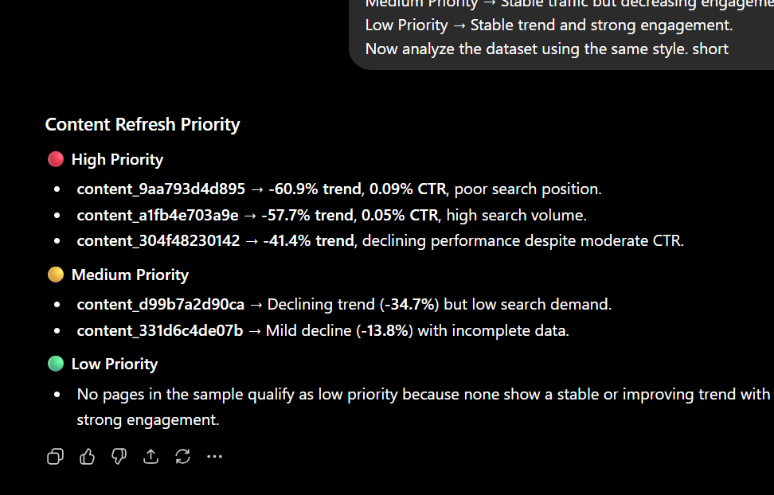

Representative Output
The AI followed the example and grouped pages into High, Medium, and Low priority.

What Changed
Providing an example improved consistency and made the recommendations easier to understand.

Version 4 – Technique: Output Structure

Prompt
Analyze the Content Refresh dataset. Present the answer as a table with Page Priority, Reason, Supporting Metrics, and Recommended Action.
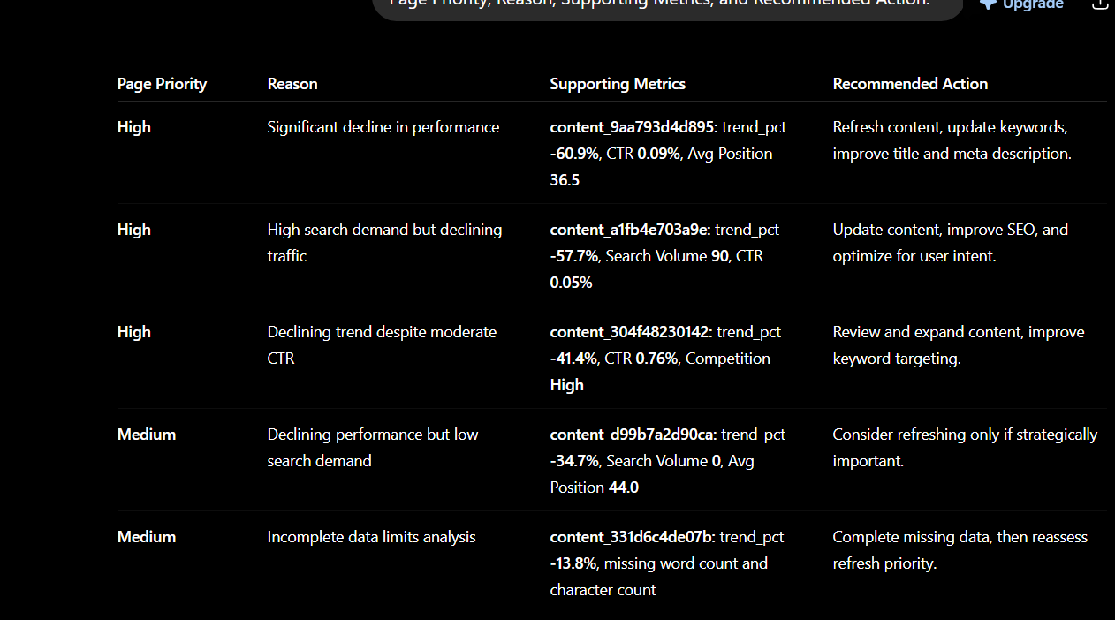

Representative Output
Page Priority | Reason | Supporting Metrics | Recommended Action
High | Declining trend | CTR, trend_pct | Refresh immediately

What Changed
The structured output made the information easier to compare and use.

Version 5 – Technique: Step Decomposition

Prompt
Analyze the dataset in these steps:
- Identify declining pages.
- Evaluate SEO metrics.
- Assign refresh priority.
- Explain your reasoning.
- Recommend an action.

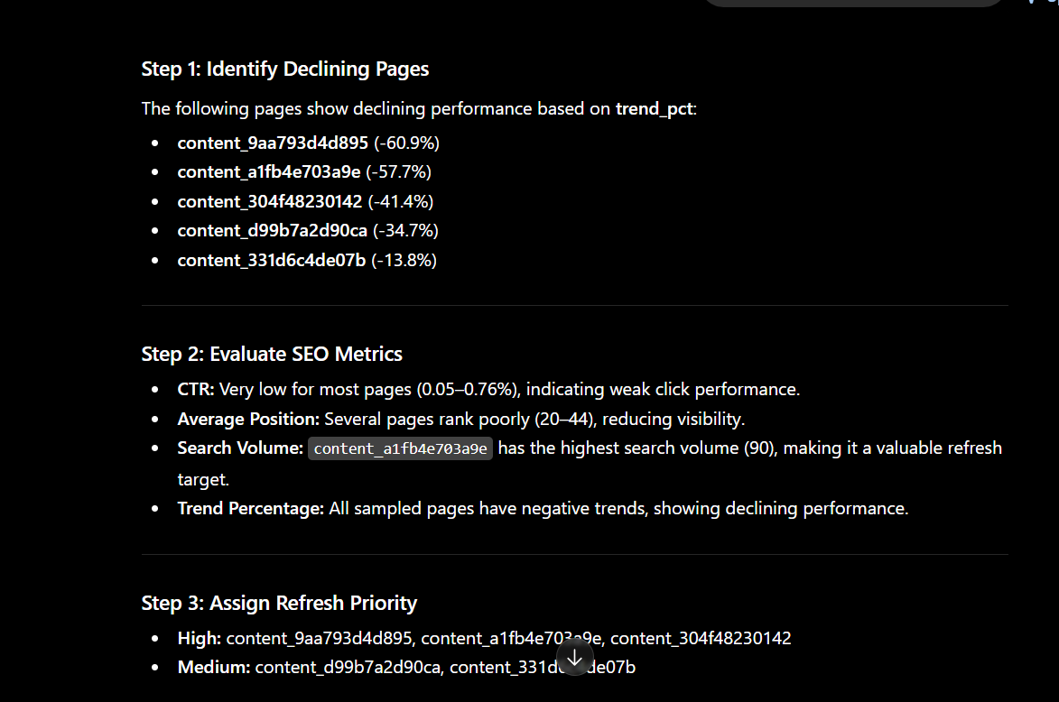
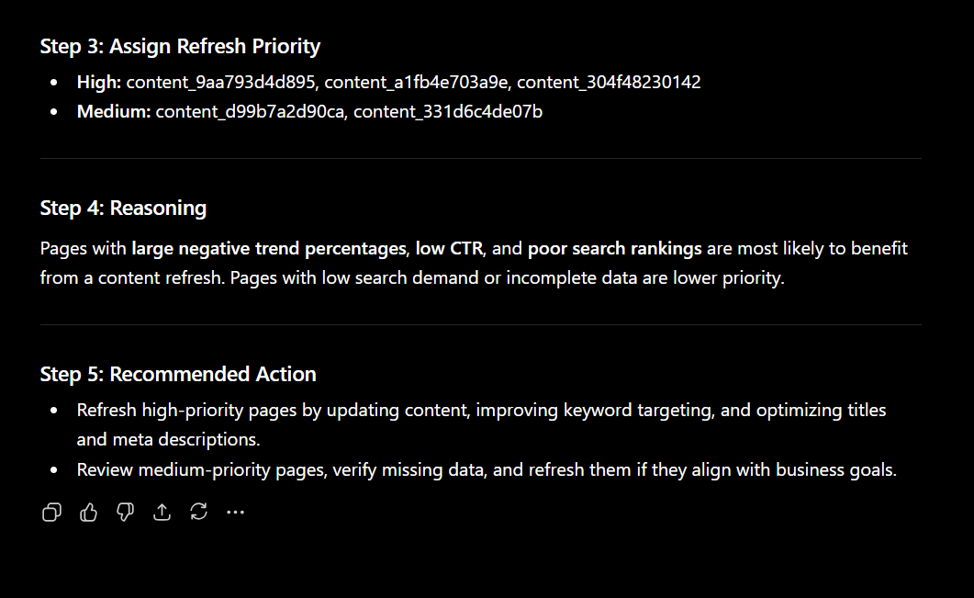

Representative Output
The response followed each step in order and provided clearer explanations for every recommendation.

What Changed
Breaking the task into steps produced a more organized and complete analysis.

Cross-Model Comparison

Claude
Claude produced more detailed explanations and better connected the recommendations to the business goal. The writing style was natural and easy to follow.

ChatGPT
ChatGPT produced a clearer structure and concise recommendations. The response was easier to scan and included practical explanations for each recommendation.

Honest Comparison
Both models produced useful results. Claude was stronger at detailed reasoning, while ChatGPT presented the information in a more structured and readable format. Both models still depended on the quality of the prompt and the available dataset.

Final Reusable Prompt Template
You are an SEO analyst helping a content team prioritize content refresh opportunities. Analyze the provided dataset using SEO metrics such as search volume, competition, CTR, average position, engagement rate, and trend percentage.
Follow these steps:
- Identify pages with declining performance.
- Evaluate the important SEO metrics.
- Assign a priority level (High, Medium, Low).
- Explain the reason using at least two metrics.
- Recommend a practical action.
Present the results as a table with Page Priority, Reason, Supporting Metrics, and Recommended Action. Avoid unsupported assumptions and base every recommendation on the available data.
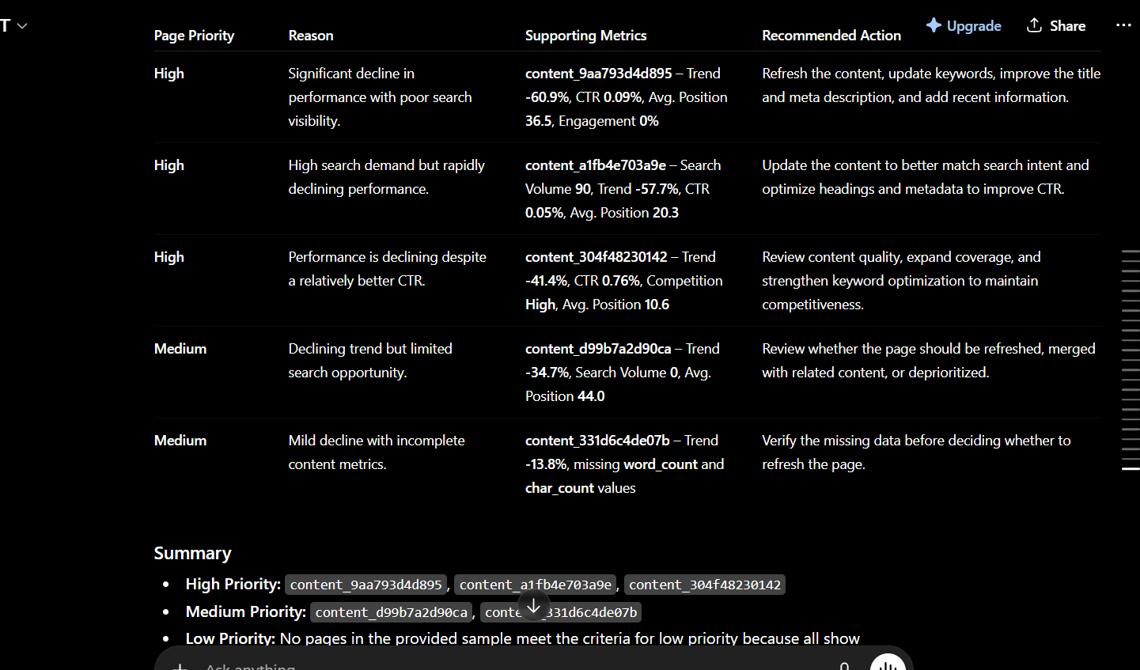

Reflection: This exercise showed me that small prompt improvements can significantly improve AI responses. Adding a role, context, examples, output structure, and step-by-step instructions produced responses that were more accurate, practical, and easier to understand than the original one-line prompt.

